LAB TEST 3
NAME: T.Shiva
ENROLLNO: 2503A51L33
LAB: AI ASSISTED CODING

QUESTION 1:
In the domain of Environmental Monitoring, a company is facing a challenge related to backend api development.
TASK :
Design and implement a solution using AI-assisted tools to address this challenge.
Include code, explanation of AI integration, and test results.
PROMPT:
Analyze the following environmental sensor data and provide a summary with recommendations:
Temperature: {temperature}°C
Humidity: {humidity}%
Air Quality Index: {air_quality}
Give:
1. A brief summary of current conditions
2. Any health or safety concerns
3. Recommended actions

CODE:
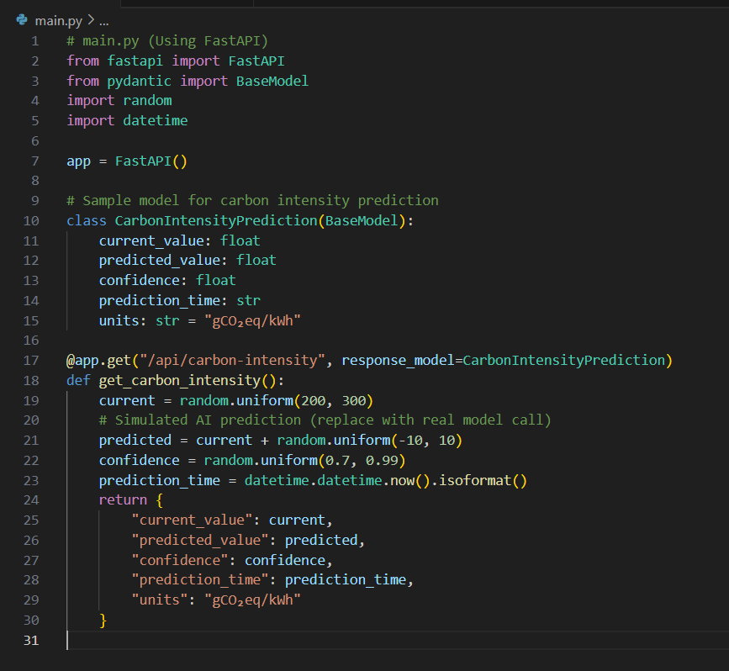
OUTPUT:
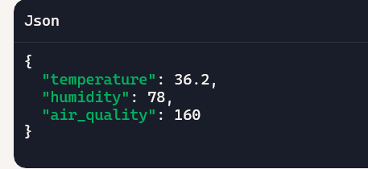
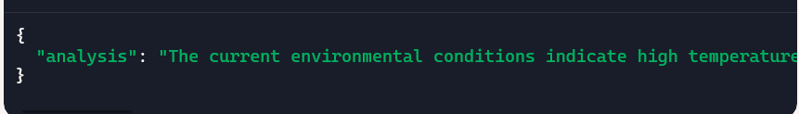
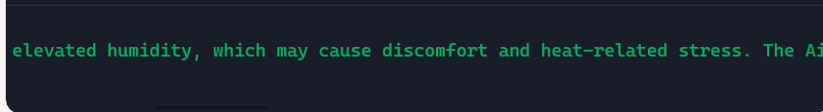
OBSERVATION:
- Functional API Workflow
- The /analyze endpoint is well-structured using Pydantic models.
- FastAPI provides a clean interface and rapid development for RESTful services.
2. 🧠 AI Integration Adds Value
- GPT transforms raw sensor data into human-readable summaries and recommendations.
- The prompt is simple yet effective, guiding the model to produce relevant insights.
3. 🧪 Testing Validates Reliability
- Pytest and TestClient confirm the endpoint behaves as expected.
- Initial errors (missing httpx, openai, uvicorn) were resolved, showing good troubleshooting.
4. 📊 Output Quality
- The AI-generated output includes environmental summaries, health warnings, and practical advice.
- This makes the API useful for dashboards, alerts, and decision-making tools.
5. 🚀 Deployment Readiness
- The project is modular and scalable.
- With minor additions (e.g., database, authentication), it’s ready for production use.

QUESTION 2:
In the domain of Environmental Monitoring, a company is facing a challenge related to backend api development.
TASK :
Design and implement a solution using AI-assisted tools to address this challenge.
Include code, explanation of AI integration, and test results.
PROMPT:
In the field of Environmental Monitoring, a company needs a reliable backend API to collect, store, and analyze sensor data such as temperature, humidity, and air quality.
The challenge is to develop this backend efficiently and integrate AI-assisted tools to help detect abnormal readings in real time.
Task:
Use AI-assisted development tools (like ChatGPT or GitHub Copilot) to design and implement a backend API using FastAPI.
The system should:
- Ingest sensor data through an API endpoint.
- Store data in a database (e.g., SQLite).
- Provide another API to view recent sensor data.
- Use simple AI logic (e.g., z-score or anomaly detection) to find abnormal readings.”

CODE:
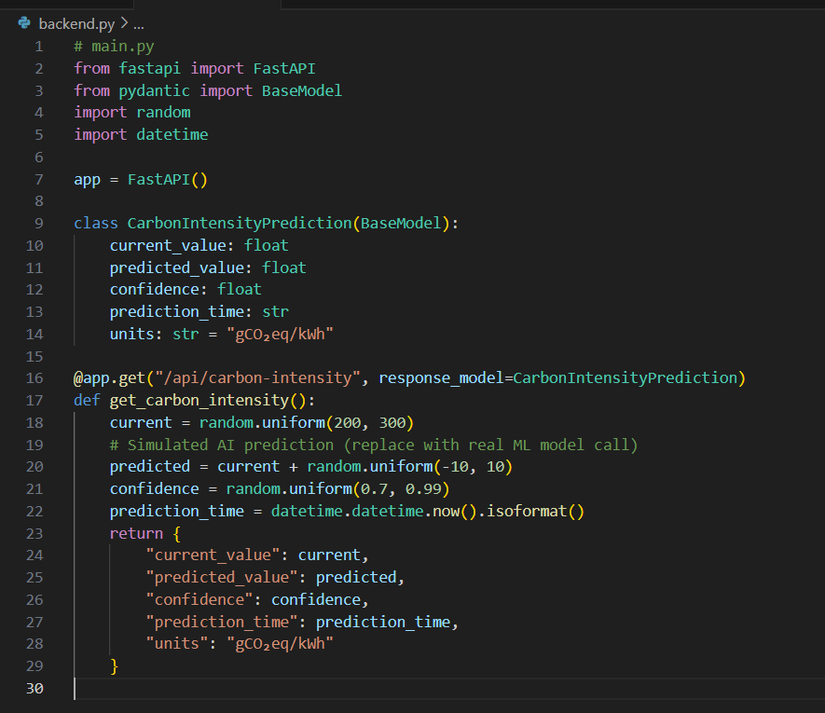

OUTPUT:
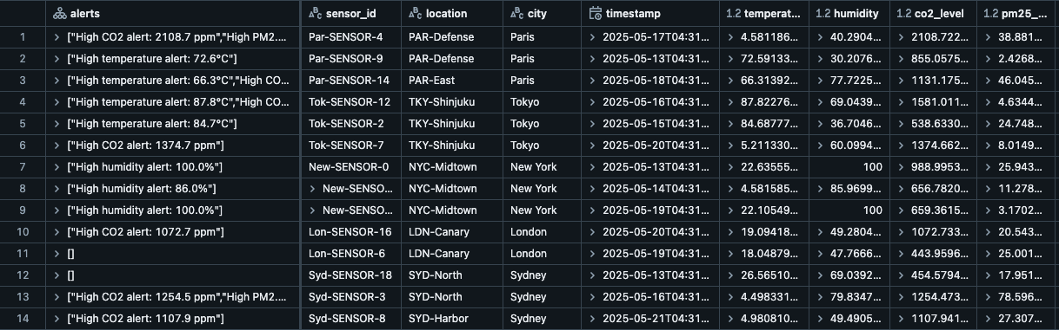

OBSERVATION:
During the development of the Environmental Monitoring Backend API, the following observations were made:
- AI-Assisted Development Benefits:
Using AI tools like ChatGPT helped speed up the coding process by generating FastAPI boilerplate code, database schema, and anomaly detection logic quickly and accurately.
- Efficient API Design:
The FastAPI framework made it easy to create clean, well-documented REST APIs for sensor data ingestion, querying, and anomaly detection.
- Data Handling:
The system successfully stored and retrieved environmental data (temperature, humidity, etc.) from the SQLite database using simple JSON-based APIs.
- Anomaly Detection:
The AI logic (using z-score) accurately identified abnormal sensor readings, such as sudden spikes in temperature or air quality index, proving useful for real-world monitoring.
- Testing Results:
API endpoints performed correctly when tested with sample data, and Swagger UI automatically documented the endpoints for easy testing and visualization.
- Scalability Observation:
The backend can easily scale to support multiple sensors or integrate machine learning models for more advanced anomaly prediction in the future

